Js event IMPORTANT!

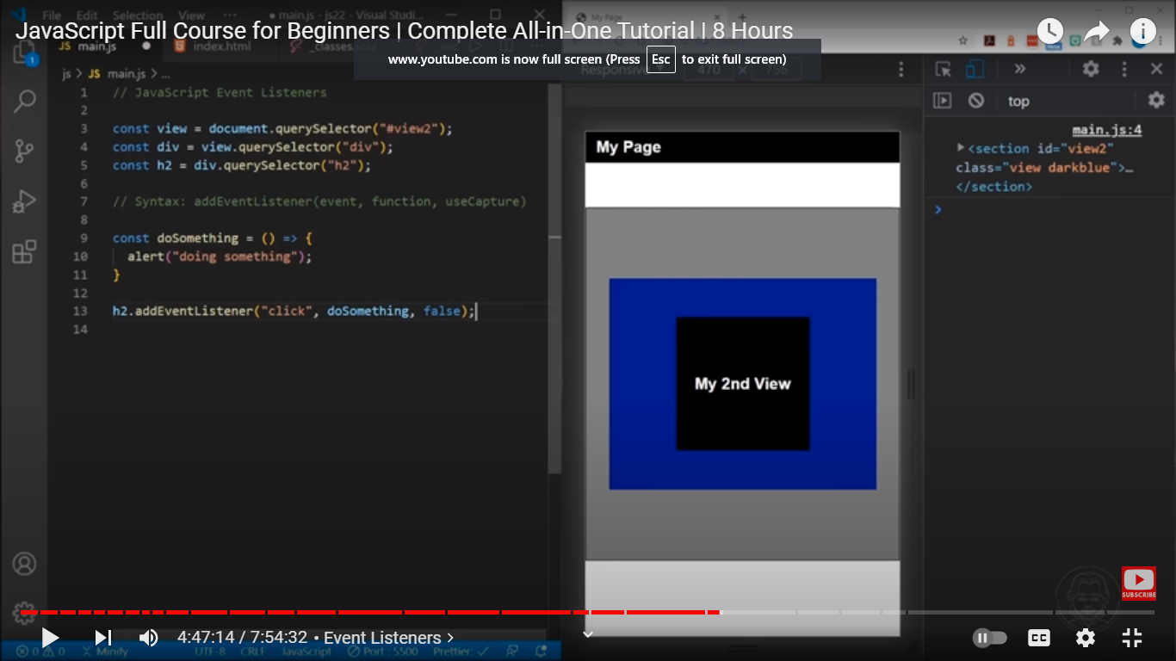

**To add & remove event listener synatx**

* Object.addEventListener(event, function, useCapture)
* Object.removeEventListener(event, fucntion)

anonymous event function:

object.addEventListener("click", (event) =>{

} );

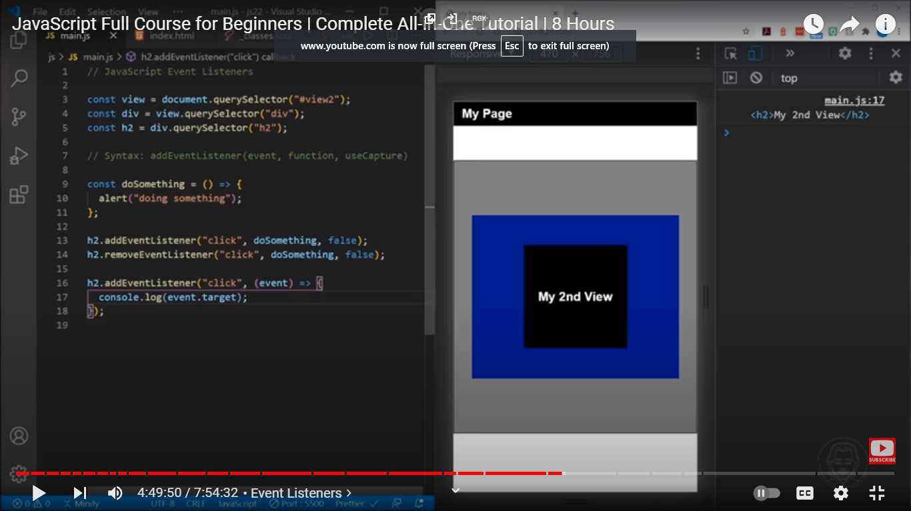

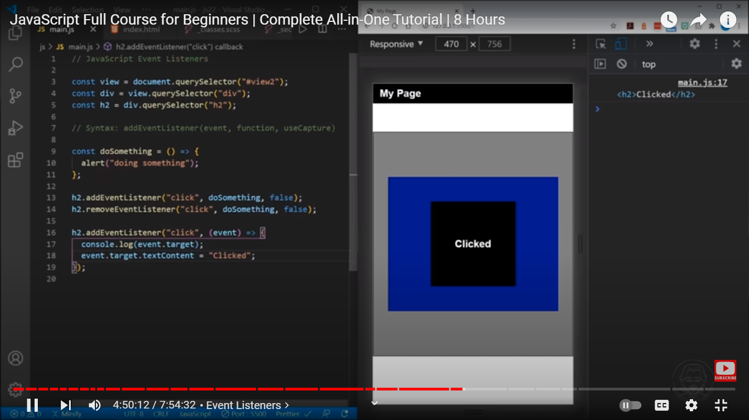

With the function keyword

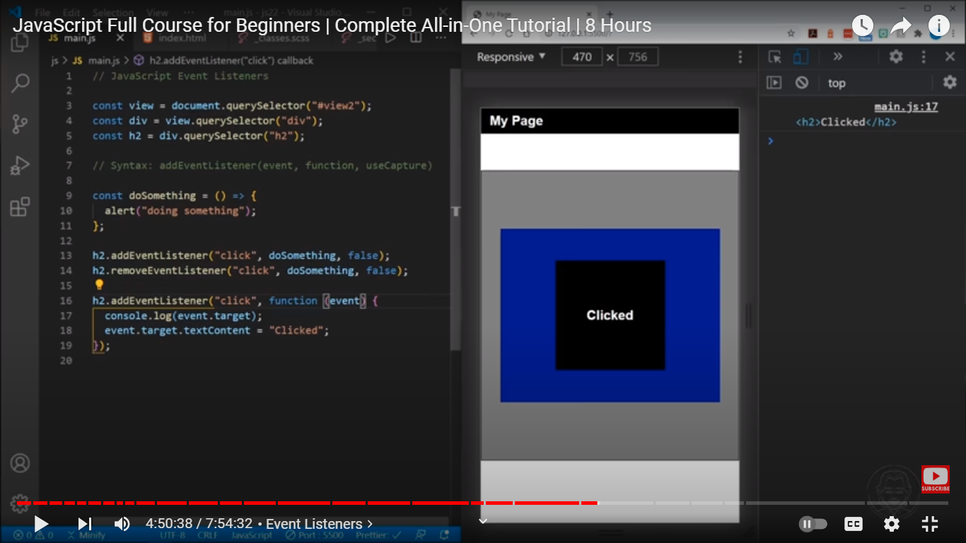

**Document Ready State**

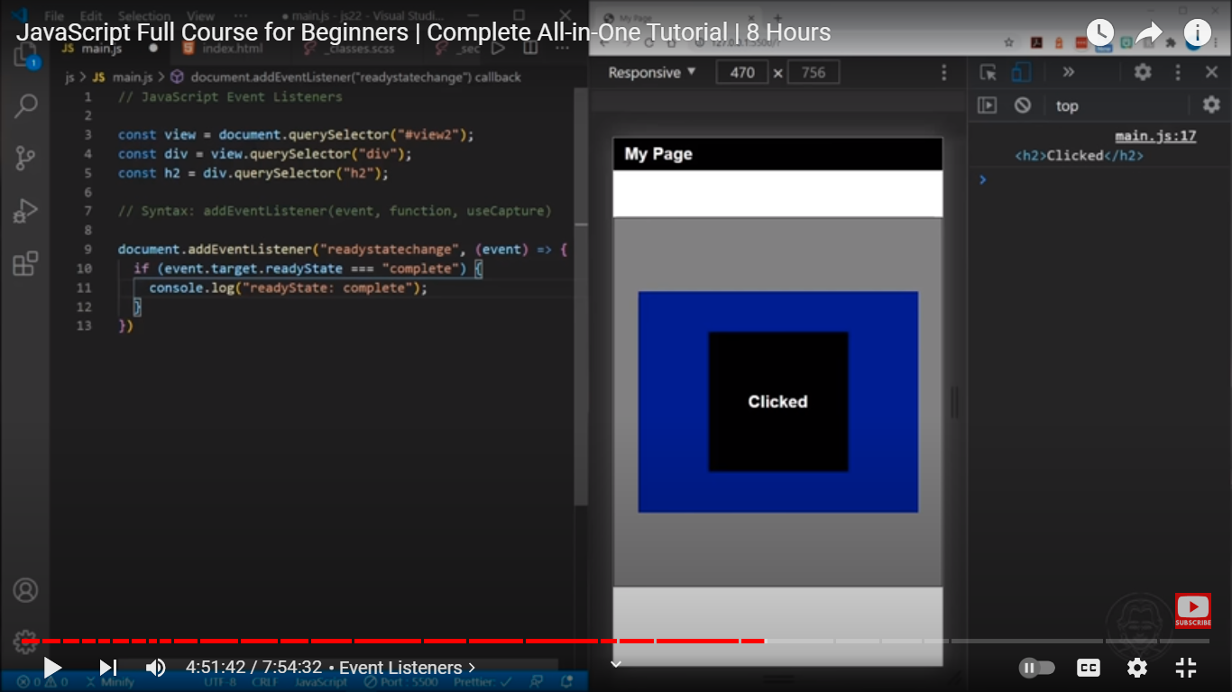

initApp() function in readystate

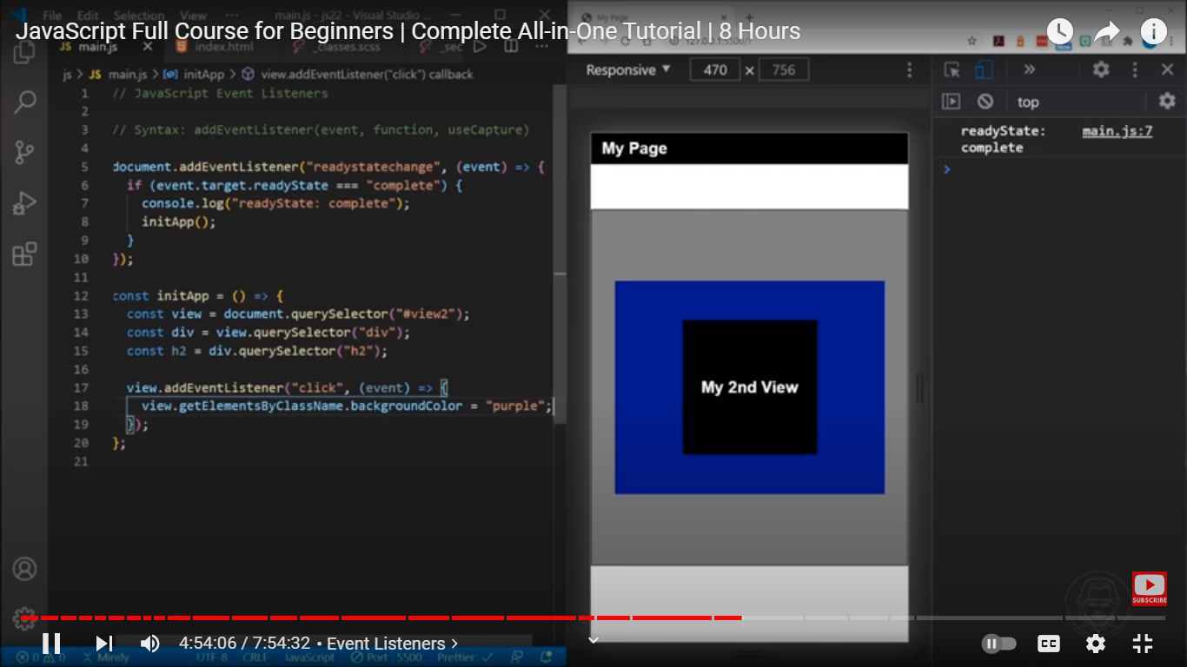

**Event target textcontent:**

Reading textContent from a node

To get the text content of a node and its descendants, you use the textContent property:

let text = node.textContent;

Suppose that you have the following HTML snippet:

<div id="note">

JavaScript textContent Demo!

<span style="display:none">Hidden Text!</span>

<!-- my comment -->

</div>

The following example uses the textContent property to get the text of the <div> element:

let note = document.getElementById('note');

console.log(note.textContent);

**Differences from innerText**

Don't get confused by the differences between Node.textContent and HTMLElement.innerText. Although the names seem similar, there are important differences:

textContent gets the content of all elements, including <script> and <style> elements. In contrast, innerText only shows "human-readable" elements.

textContent returns every element in the node. In contrast, innerText is aware of styling and won't return the text of "hidden" elements.

Moreover, since innerText takes CSS styles into account, reading the value of innerText triggers a reflow to ensure up-to-date computed styles. (Reflows can be computationally expensive, and thus should be avoided when possible.)

